Process to import document (specifically .csv) into MongoDB Compass collection.

**\*\*This is tried and tested by both myself and MongoDB Support staff, as verified by a 4-hour support session, with equal amounts of confusion on both sides as to certain errors received.**

**\*This is just for the process to upload, this assumes you have created, correctly logged in, and connected to your cluster, as we won’t really be using the MongoDB Compass application for it.**

**MongoDB Information:**

* Database name: LDB
  + Location Database
* Collection Name: LC
  + Location Collection

1. First, we need to download MongoDB Database Tools.
   1. The process to do so is [here](https://docs.mongodb.com/database-tools/installation/installation-windows/).
2. Once it is downloaded and you have successfully set your PATH variable to the installation directory, we first need to verify that port 27017 is not being used by other local service instances. Launch Command Prompt as an administrator.
   1. Run the command *netstat –ano |findstr “27017”*
   2. If there are any processes listed as ‘LISTENING’ instead of ‘ESTABLISHED’ you have to end those processes via [this process](https://www.tp-link.com/us/support/faq/1483/#:~:text=Open%20the%20Command%20Line%20of,the%20PID%20of%20the%20process.).
   3. Exit Command Prompt.
3. Launch a new instance of Command Prompt (not as administrator), then navigate to the directory where it is installed, then to the bin folder via this command:
   1. cd C:\Program Files\MongoDB\Tools\100\bin
4. Once in this directory, we need to utilize the *mongoimport* command. We will find this by:
   1. Visiting mongodb.com, then log in with account information.
   2. In what should be the base website you’re brought to (Deployment > Database), click on the Cluster name, in the picture below it is ‘Cluster0’

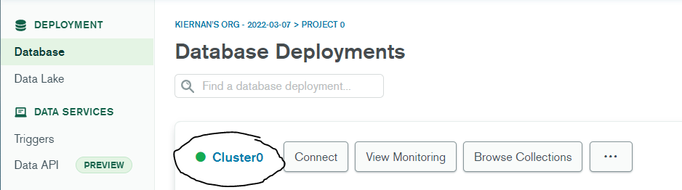

* 1. Next, click on the ‘Cmd Line Tools’ tab highlighted below.

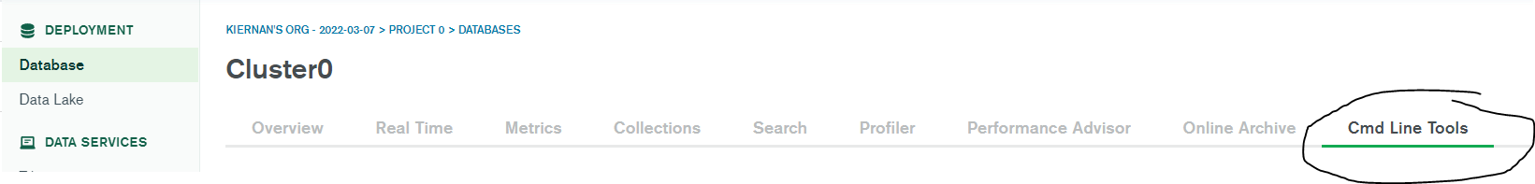

* 1. Then, you will scroll down to ‘Data Import and Export Tools’, and the mongoimport via URI command will be there. You need to copy it.

1. Copy and paste the *mongoimport* command below, and replace fields with <> around them with correct fields.
   1. Base Case:
      1. mongoimport --uri mongodb+srv://ecko:<PASSWORD>@cluster0.fp474.mongodb.net/<DATABASE> --collection <COLLECTION> --type <FILETYPE> --file <FILENAME>
   2. Our Case:
      1. mongoimport --uri mongodb+srv://ecko:<PASSWORD>@cluster0.fp474.mongodb.net/LDB --collection LC --type csv --file C:\Users\Kiernan\Downloads\mongodbsheet1.csv --headerline
2. After you hit ‘enter’ with that command, you should have a successful import into the Location Collection, with each object being an ordered pair of (longitude, latitude).
   1. See successful import below:

